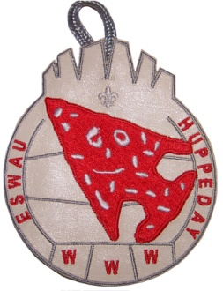
Eswau Huppeday
Castaway “Wilson” Pre- order Form

Number of patches $3 x ________ = ____________
Shipping $3 per order ____________
20 or more patches free shipping Total ___________
You may opt to pickup your order at the Lodge Fall Fellowship September 13
Ship to
Name__________________________________________________
Address________________________________________________
City/state/zip___________________________________________
Phone number/email_____________________________________
ABSOLUTE ORDER DEADLINE AUGUST 4TH
Questions during summer camp should be directed to Lodge Chief Matt Cook
You may order as many patches as you like, they are not restricted to just Eswau Huppeday members.
Mail payment check to
Eswau Huppeday
Jimmy Arthurs
181 Oak Meadow Drive
Mooresville NC 28155

