2019
34th Annual
Carolinas O.A.
Indian Seminar
Mitchell Community College Continuing Education Center
Statesville, North Carolina
January 25th -27th, 2019

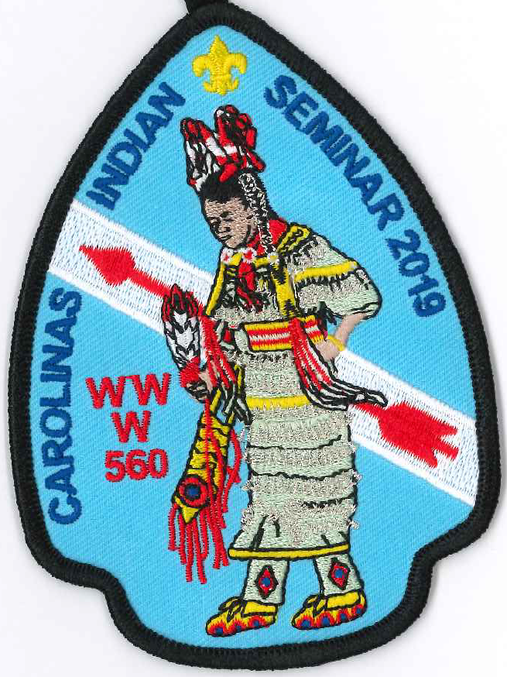

Eswau Huppeday Lodge
Piedmont Council, North Carolina
Boy Scouts of AmericA

IMPORTANT NOTE
The cafeteria is CLOSED. Meals will be served in the lobby on the ground floor of the Workforce Building (New classroom building)

2019 Carolinas OA Indian Seminar
Friday January 25, 2019
5:00 - 11:00 PM | Registration
8:30 - 10:30 PM | Powwow / Styles Overview
12:00 Midnight | Lights out
Saturday January 26, 2019
7:00 AM | Reveille / Clear all training areas
7:30 AM | Breakfast A
8:00 AM | Breakfast B
9:00 - 10:25 AM | First Training Session
10:30 - 11:55 AM | Second Training Session
12:00 Noon | AICA Committee Meeting
12:00 Noon | Lunch A
12:30 PM | Lunch B
1:30 - 2:55 PM | Third Training Session
3:00 - 4:25 PM | FourthTraining Session
4:30 - 5:30 PM | Fifth Training Session
5:30 PM | Dinner A
6:00 PM | Dinner B
7:15 PM | Gourd Dance (Tentative)
8:15 PM | PowWow
12:00 Midnight | Lights out
Sunday January 27, 2019
7:00 AM | Reveille / Pack up
7:30 AM | Vespers Service
9:00 - 10:00 AM | Leave for home - Have a safe trip!

Please visit the vendors in the Gym Lobby and Main upstairs hallway.

We are fortunate to have large and small vendors at the Carolina Indian Seminar. They are a tradition and CIS would not be successful without them. Participants who have small sales tables will set up in the main upstairs hallway in front of the Auditorium and around classrooms 4,5,8,9, and 10.

Only Flying Feathers is permitted in the Gym Lobby.

2019 Carolinas Indian Seminar Principals and Key Staff

Logan Thompson - Head Man Dancer Abby Barton - Head Lady Dancer
Kyle Furgason - Master of Ceremonies Caleb Barnes - Head Singer
Ethan Spence - Arena Director Tammy Miller - CIS Program Director
Rodney Bobak – Worship Leader Randy Wallace - Food Services Advisor
Jimmy Arthurs – Facilities Director Abbie Teeple - CIS Advisor

The Carolina’s OA Indian Seminar thanks the following individuals/groups for making this event a success:
- Ms. Carol Johnson and Ms. Cheryl Sells - Mitchell Community College Continuing Education
- Eswau Huppeday Lodge Brothers- All the irksome tasks and weighty responsibilities
- And all of the Ladies and Gentlemen who serve as Indian Seminar Instructors, Support Staff and Principals!

Year Location MC Head Man Head Lady
1985 Statesville Armory ?Mark Gantt ?Steve Watts Cyndy Pierce
1986 Mooresville Armory ?Steve Watts ?Scott Alexander ?
1987 Mooresville Armory Scott Alexander Bobby Swink Betsy Jonas
1988 Woods School Steve Watts *Kevin Gantt Betsy Kesler
1989 War Memorial Rec Kevin Gantt *Greg Monroe Kim Riley
1990 War Memorial Rec Jim Ross *Ivan Engler Jeanne Jamison
1991 Old N-C Jr High Mark Gantt *Darrin Gantt Millie Pierce
1992 Camp Bud Schiele Greg Monroe *Brent Hincher Brandee Ross
1993 MCC Continuing Ed Brent Hincher Trevore Ross Millie Pierce
1994 MCC Continuing Ed Darin Gantt *Scott Neely Kay Burnett
1995 MCC Continuing Ed Erik Neely Steven Reaves Kristen Biddinger
1996 MCC Continuing Ed Trevore Ross Chris Bowen Autumn LaQuay
1997 MCC Continuing Ed Jason Pope Michael Hartnett Ashley Feaselman
1998 MCC Continuing Ed Chip Wilson Chris Bryant Tina DiBalsi
1999 MCC Continuing Ed Lou Bell *Chip Wilson Amy Dean
2000 MCC Continuing Ed Joe Makkos Ryan Smith Michelle Roberts
2001 MCC Continuing Ed Chuck Dubois *Joe Makkos Sasha Barefield
2002 MCC Continuing Ed Johannes Bosch Micah Englund Kim Laham
2003 MCC Continuing Ed John Garwood Brandon Gregory Katie Brestel-Ohle
2004 MCC Continuing Ed Adam Bartley Blake Bain Brenna White
2005 MCC Continuing Ed John Garwood *Brian Manuel Carrie Barlowe
2006 MCC Continuing Ed John Garwood Max Cartwright Shenna Anderson
2007 MCC Continuing Ed John Garwood Amos London Carrie Barlowe
2009 MCC Continuing Ed Amos London Jackson Gantt Jamie Washburn
2010 MCC Continuing Ed Robbie Miller Will Garwood Heather Durough
2011 MCC Continuing Ed Robbie Miller Isaac London Angel Gray
2012 MCC Continuing Ed Mitchell Harbin Charles Gaither Jamie Washburn
2013 MCC Continuing Ed Mitchel Harbin John Borden Jamie Washburn
2014 MCC Continuing Ed Nathan Davis Justin Cobb Catherine Ritchie
2015 MCC Continuing Ed Nathan Davis Caleb Barnes Kiera O’Neill
2016 Cancelled due to snow storm
2017 MCC Continuing Ed Taylor Everard Alex Barton Keeli O’Neill
2018 MCC Continuing Ed Robbie Bass Eli Kayne Caitlin Barnes
*Denotes National Order of the Arrow Conference Champion

We would like to thank and recognize our past principals. If you served as a principal in years past and can clarify any of the above items, please let Ed know. Thanks.
CIS Instructors’ Email Addresses

First Name | Last Name | E-MAIL | First Name | Last Name | E-MAIL
Jerry | Andrews | toJerry@charter.net | Taylor | Everhard
Robin | Andrews | toRobin@charter.net | Kevin | Gantt | kevingantt@charter.net
Jimmy | Arthurs | jcarthu@aol.com | Mikkie | Goins | Michael.Goins@cns.doe.gov
James | Barton | quitnot71@gmail.com | Steve | Hand | xnaveod@gmail.com
Hank | Birdsong | hbirdsong@gmail.com | Michael | Hartje | frontiermike1@gmail.com
Mark | Birdsong | mark@camppage.com | Michael | Hartnett | mhartn1049@aol.com
Benjamin | Birdsong | btbirdsong@yahoo.com | Ken | Hood | shugah24@hotmail.com
Rodney | Bobak | rodneyjbobak@gmail.com | Dixie | Jordan | buffalomorning@yahoo.com
Greg | Boone | boonegh@gmail.com | Jim | Kurtts | jnk4@bellsouth.net
Danny | Bowman |  | Bill | Morris | bmorris3@nc.rr.com
Jeff | Brewer | jdbrewer104@gmail.com | Kevin | O'Neill | oneill2u@yahoo.com
Chris | Bryant | mtnempr57@yahoo.com | Mark | Parman | mark-parman@cherokee.org
Eddie | Cahoon | eccahoon@aol.com | Matthew | Penland | mpenland1979@hotmail.com
Steve | Campbell | stevenwcampbell.104@gmail.com | Jim | Ross | ros@carol.net
Justin | Cobb | cobbj94@gmail.com | Russell | Schmidt | ruseagle@hotmail.com
David | Cody | djcody@charter.net | Tim | Sering | trsering@me.com
David | Dean |  | Ken | Shabaz | kshahbaz@sscocpa.com
Chris | DeHart | dehartt@floydcountyga.org | Chandler | Steele | csteele021@gmail.com
Ed | DeTorres | exdt@webtv.net | Ellis | Taylor | brerfox413@gmail.com
Dennis | DuBois | dennis7767@icloud.com | Logan | Thompson | chicknhawk117@gmail.com
Nina | Dukes | ninacdukes@gmail.com | Darry | Wood | buckcreekwoods@gmail.com
Bill | Dyar | billdyar@frontier.com | Robin/Tim | Ziolkowski | shorty_sis@hotmail.com

