2019

*34th Annual*

Carolinas O.A.

Indian Seminar

Mitchell Community College Continuing Education Center

Statesville, North Carolina

January 25th -27th, 2019

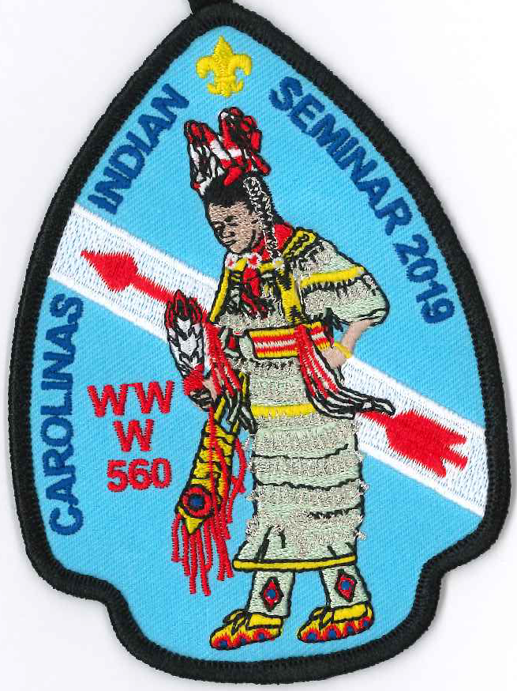

Eswau Huppeday Lodge

Piedmont Council, North Carolina

Boy Scouts of AmericA

**IMPORTANT NOTE**

**The cafeteria is CLOSED. Meals will be served in the lobby on the ground floor of the Workforce Building (New classroom building)**

|  |  |
| --- | --- |
| ***2019 Carolinas OA Indian Seminar*** | |
| **Friday January 25, 2019** | |
| 5:00 - 11:00 PM | Registration |
| 8:30 - 10:30 PM | Powwow / Styles Overview |
| 12:00 Midnight | Lights out |
| **Saturday January 26, 2019** | |
| 7:00 AM | Reveille / Clear all training areas |
| 7:30 AM | Breakfast A |
| 8:00 AM | Breakfast B |
| 9:00 - 10:25 AM | First Training Session |
| 10:30 - 11:55 AM | Second Training Session |
| 12:00 Noon | AICA Committee Meeting |
| 12:00 Noon | Lunch A |
| 12:30 PM | Lunch B |
| 1:30 - 2:55 PM | Third Training Session |
| 3:00 - 4:25 PM | FourthTraining Session |
| 4:30 - 5:30 PM | Fifth Training Session |
| 5:30 PM | Dinner A |
| 6:00 PM | Dinner B |
| 7:15 PM | Gourd Dance (Tentative) |
| 8:15 PM | PowWow |
| 12:00 Midnight | Lights out |
| **Sunday January 27, 2019** | |
| 7:00 AM | Reveille / Pack up |
| 7:30 AM | Vespers Service |
| 9:00 - 10:00 AM | Leave for home - ***Have a safe trip!*** |

**Please visit the vendors in the Gym Lobby and Main upstairs hallway.**

We are fortunate to have large and small vendors at the Carolina Indian Seminar. They are a tradition and CIS would not be successful without them. Participants who have small sales tables will set up in the main upstairs hallway in front of the Auditorium and around classrooms 4,5,8,9, and 10.

**Only Flying Feathers is permitted in the Gym Lobby.**

2019 Carolinas Indian Seminar Principals and Key Staff

Logan Thompson - Head Man Dancer Abby Barton - Head Lady Dancer

Kyle Furgason - Master of Ceremonies Caleb Barnes - Head Singer

Ethan Spence - Arena Director Tammy Miller - CIS Program Director

Rodney Bobak – Worship Leader Randy Wallace - Food Services Advisor

Jimmy Arthurs – Facilities Director Abbie Teeple - CIS Advisor

The Carolina’s OA Indian Seminar thanks the following individuals/groups for making this event a success:

* Ms. Carol Johnson and Ms. Cheryl Sells - Mitchell Community College Continuing Education
* Eswau Huppeday Lodge Brothers- All the irksome tasks and weighty responsibilities
* And all of the Ladies and Gentlemen who serve as Indian Seminar Instructors, Support Staff and Principals!

Year Location MC Head Man Head Lady

1985 Statesville Armory ?Mark Gantt ?Steve Watts Cyndy Pierce

1986 Mooresville Armory ?Steve Watts ?Scott Alexander ?

1987 Mooresville Armory Scott Alexander Bobby Swink Betsy Jonas

1988 Woods School Steve Watts *Kevin Gantt Betsy Kesler

1989 War Memorial Rec Kevin Gantt *Greg Monroe Kim Riley

1990 War Memorial Rec Jim Ross *Ivan Engler Jeanne Jamison

1991 Old N-C Jr High Mark Gantt *Darrin Gantt Millie Pierce

1992 Camp Bud Schiele Greg Monroe *Brent Hincher Brandee Ross

1993 MCC Continuing Ed Brent Hincher Trevore Ross Millie Pierce

1994 MCC Continuing Ed Darin Gantt *Scott Neely Kay Burnett

1995 MCC Continuing Ed Erik Neely Steven Reaves Kristen Biddinger

1996 MCC Continuing Ed Trevore Ross Chris Bowen Autumn LaQuay

1997 MCC Continuing Ed Jason Pope Michael Hartnett Ashley Feaselman

1998 MCC Continuing Ed Chip Wilson Chris Bryant Tina DiBalsi

1999 MCC Continuing Ed Lou Bell *Chip Wilson Amy Dean

2000 MCC Continuing Ed Joe Makkos Ryan Smith Michelle Roberts

2001 MCC Continuing Ed Chuck Dubois *Joe Makkos Sasha Barefield

2002 MCC Continuing Ed Johannes Bosch Micah Englund Kim Laham

2003 MCC Continuing Ed John Garwood Brandon Gregory Katie Brestel-Ohle

2004 MCC Continuing Ed Adam Bartley Blake Bain Brenna White

2005 MCC Continuing Ed John Garwood *Brian Manuel Carrie Barlowe

2006 MCC Continuing Ed John Garwood Max Cartwright Shenna Anderson

2007 MCC Continuing Ed John Garwood Amos London Carrie Barlowe

2009 MCC Continuing Ed Amos London Jackson Gantt Jamie Washburn

2010 MCC Continuing Ed Robbie Miller Will Garwood Heather Durough

2011 MCC Continuing Ed Robbie Miller Isaac London Angel Gray

2012 MCC Continuing Ed Mitchell Harbin Charles Gaither Jamie Washburn

2013 MCC Continuing Ed Mitchel Harbin John Borden Jamie Washburn

2014 MCC Continuing Ed Nathan Davis Justin Cobb Catherine Ritchie

2015 MCC Continuing Ed Nathan Davis Caleb Barnes Kiera O’Neill

2016 Cancelled due to snow storm

2017 MCC Continuing Ed Taylor Everard Alex Barton Keeli O’Neill

2018 MCC Continuing Ed Robbie Bass Eli Kayne Caitlin Barnes

*Denotes National Order of the Arrow Conference Champion

We would like to thank and recognize our past principals. If you served as a principal in years past and can clarify any of the above items, please let Ed know. Thanks.

CIS Instructors’ Email Addresses

|  |  |  |  |  |  |
| --- | --- | --- | --- | --- | --- |
| First Name | Last Name | E-MAIL | First Name | Last Name | E-MAIL |
| Jerry | Andrews | toJerry@charter.net | Taylor | Everhard |  |
| Robin | Andrews | toRobin@charter.net | Kevin | Gantt | kevingantt@charter.net |
| Jimmy | Arthurs | jcarthu@aol.com | Mikkie | Goins | Michael.Goins@cns.doe.gov |
| James | Barton | quitnot71@gmail.com | Steve | Hand | xnaveod@gmail.com |
| Hank | Birdsong | hbirdsong@gmail.com | Michael | Hartje | frontiermike1@gmail.com |
| Mark | Birdsong | mark@camppage.com | Michael | Hartnett | mhartn1049@aol.com |
| Benjamin | Birdsong | btbirdsong@yahoo.com | Ken | Hood | shugah24@hotmail.com |
| Rodney | Bobak | rodneyjbobak@gmail.com | Dixie | Jordan | buffalomorning@yahoo.com |
| Greg | Boone | boonegh@gmail.com | Jim | Kurtts | jnk4@bellsouth.net |
| Danny | Bowman |  | Bill | Morris | bmorris3@nc.rr.com |
| Jeff | Brewer | jdbrewer104@gmail.com | Kevin | O'Neill | oneill2u@yahoo.com |
| Chris | Bryant | mtnempr57@yahoo.com | Mark | Parman | mark-parman@cherokee.org |
| Eddie | Cahoon | eccahoon@aol.com | Matthew | Penland | mpenland1979@hotmail.com |
| Steve | Campbell | stevenwcampbell.104@gmail.com | Jim | Ross | ros@carol.net |
| Justin | Cobb | cobbj94@gmail.com | Russell | Schmidt | ruseagle@hotmail.com |
| David | Cody | djcody@charter.net | Tim | Sering | trsering@me.com |
| David | Dean |  | Ken | Shabaz | kshahbaz@sscocpa.com |
| Chris | DeHart | dehartt@floydcountyga.org | Chandler | Steele | csteele021@gmail.com |
| Ed | DeTorres | exdt@webtv.net | Ellis | Taylor | brerfox413@gmail.com |
| Dennis | DuBois | dennis7767@icloud.com | Logan | Thompson | chicknhawk117@gmail.com |
| Nina | Dukes | ninacdukes@gmail.com | Darry | Wood | buckcreekwoods@gmail.com |
| Bill | Dyar | billdyar@frontier.com | Robin/Tim | Ziolkowski | shorty_sis@hotmail.com |



